
UNIVERSITY OF CYPRUS  DEPARTMENT OF COMPUTER SCIENCE | 

EPL 363

Software Engineering Professional Practice

Metrics Document

eyeReader

Marios Kelepeshis

Antrea Chrysanthou

Giorgos Hadjidemetriou

Constantinos Stylianou

<12.05.2018>

PRODUCT METRICS

System Attributes

Development Platform (e.g., PC, Mid-Range, Mainframe, Multiplatform)
The primary development platform of the system (as determined by the operating system used) is:
- Android (v6.2 and higher)

Primary Programming Language(s) (e.g., JAVA, C, C++)
The primary language used for the development:
- Javascript

Business Area Type (e.g., Manufacturing, Personnel, Finance)
The type of business area addressed by the project is:
- Journalism and News Reading

Application Type (e.g., Information System, Transaction/Production System, Process Control)
The type of application addressed by the project is:
- Information System

System Type (e.g., Real-time System, Embedded System, Distributed System, Simple Software, Web Application)
The type of software addressed by the project is:
- Real-Time System
- Web Application

Level of Case Tools Used

Case Tool | Very Low | Low | Nominal | High | Very High
Ionic Framework v1 | Yes
Visual Studio Code |  | Yes
AngularJS |  | Yes

Very Low Edit, code, debug
Low Simple front-end, back-end CASE, little integration
Nominal Basic life-cycle tools, moderately integrated
High Strong, mature life-cycle tools, moderately integrated
Very High Strong, mature, proactive life-cycle tools, well-integrated with process, methods, reuse

System Size

Lines of Code and Complexity

Metric | Value
Number of source code lines | 3886
Number of comment lines | 1115
Average complexity | 2.01
WMC (for object-oriented systems) | N/A
DIT (for object-oriented systems) | N/A
NOC (for object-oriented systems) | N/A
CBO (for object-oriented systems) | N/A

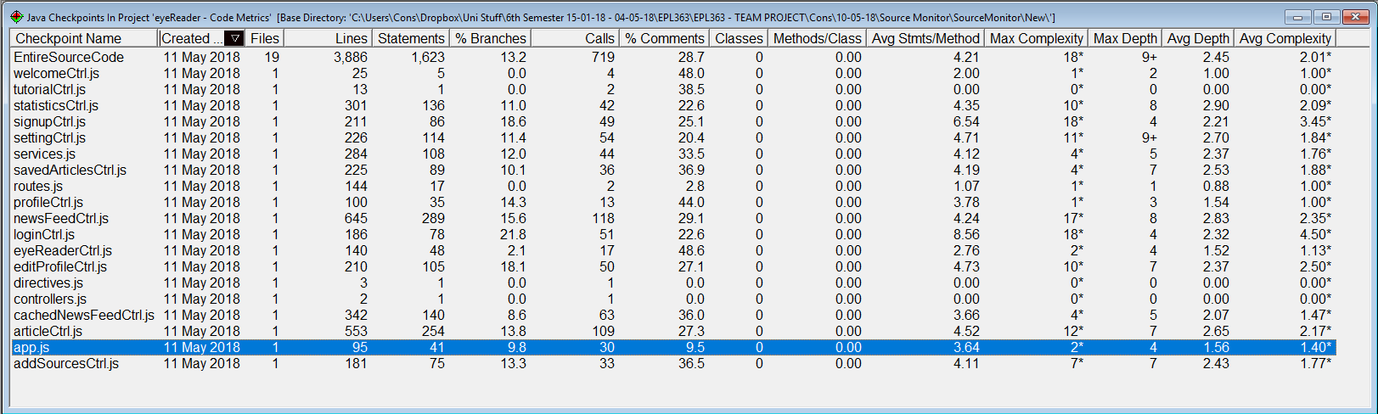
Code Metric Application Used: Source Monitor

Based on the results accumulated by Source Monitor our code’s average complexity is 2.01*. Therefore, since the preferred complexity of a block of code is 1, the complexity calculated by Source Monitor for the entirety of our app is acceptable and therefore a good indicator that our code is efficient and clear of needless lines of codes.

Number and Complexity of Modules or Classes

Number of modules/classes | Complexity
Number of modules/classes | Very Low | Low | Average | High | Very High | Total
14 |  | Yes
There are a total of 14 classes included within our application’s files. The complexity of the classes is low based on the report given by JSHint. Based on the average amount of cyclomatic complexity of all the files together accumulated by JSHint, the app’s complexity is 5 while the median complexity is 1.

Number and Complexity of Functions or Methods
Number of functions/methods | Complexity
Number of functions/methods | Very Low | Low | Average | High | Very High | Total
142 |  |  | Yes

There are a total of 142 functions included within our app’s .js files. The complexity of the functions included is high based on the report given by JSHint. Based on the average amount of cyclomatic complexity of all the functions together accumulated by JSHint, the complexity of the functions is 6 while the median complexity is 1.

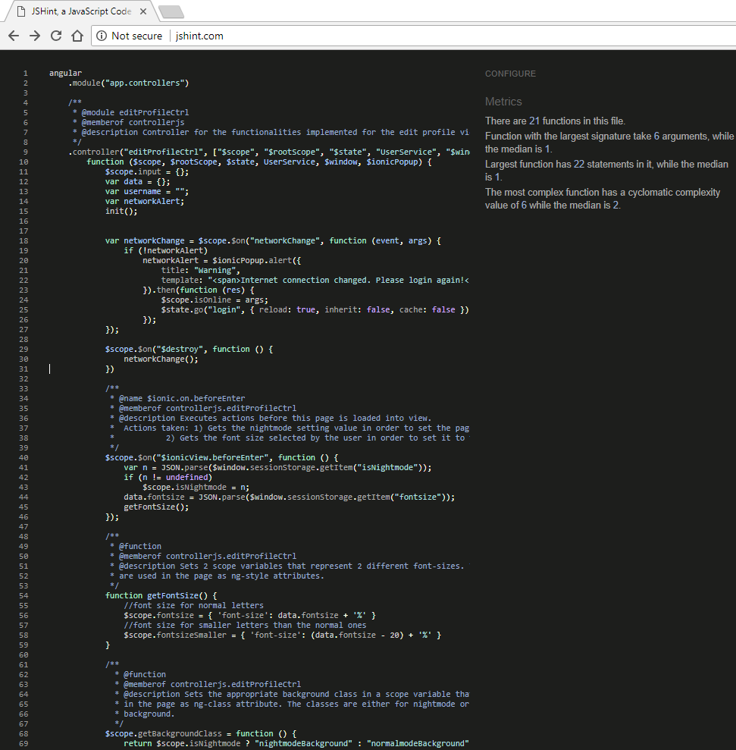
Screenshot of block of code being analysed by JSHint:

